Nama : Lilis Sonia

NIM :18090051

Kelas : 5D

**PRAKTIKUM 3**

1. Source Code

Matakuliah.php-> application/controller/matakuliah

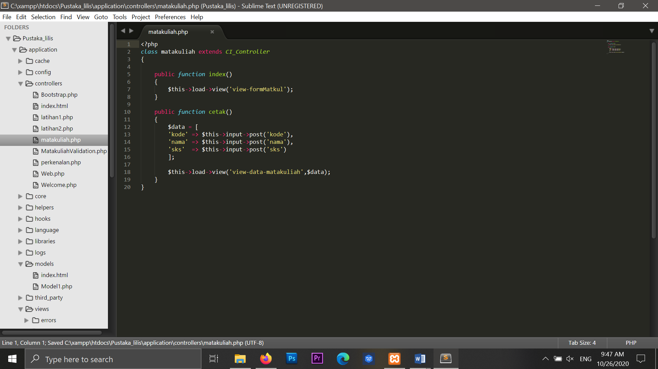

view-formMatkul.php->application/views/view-formMatkul

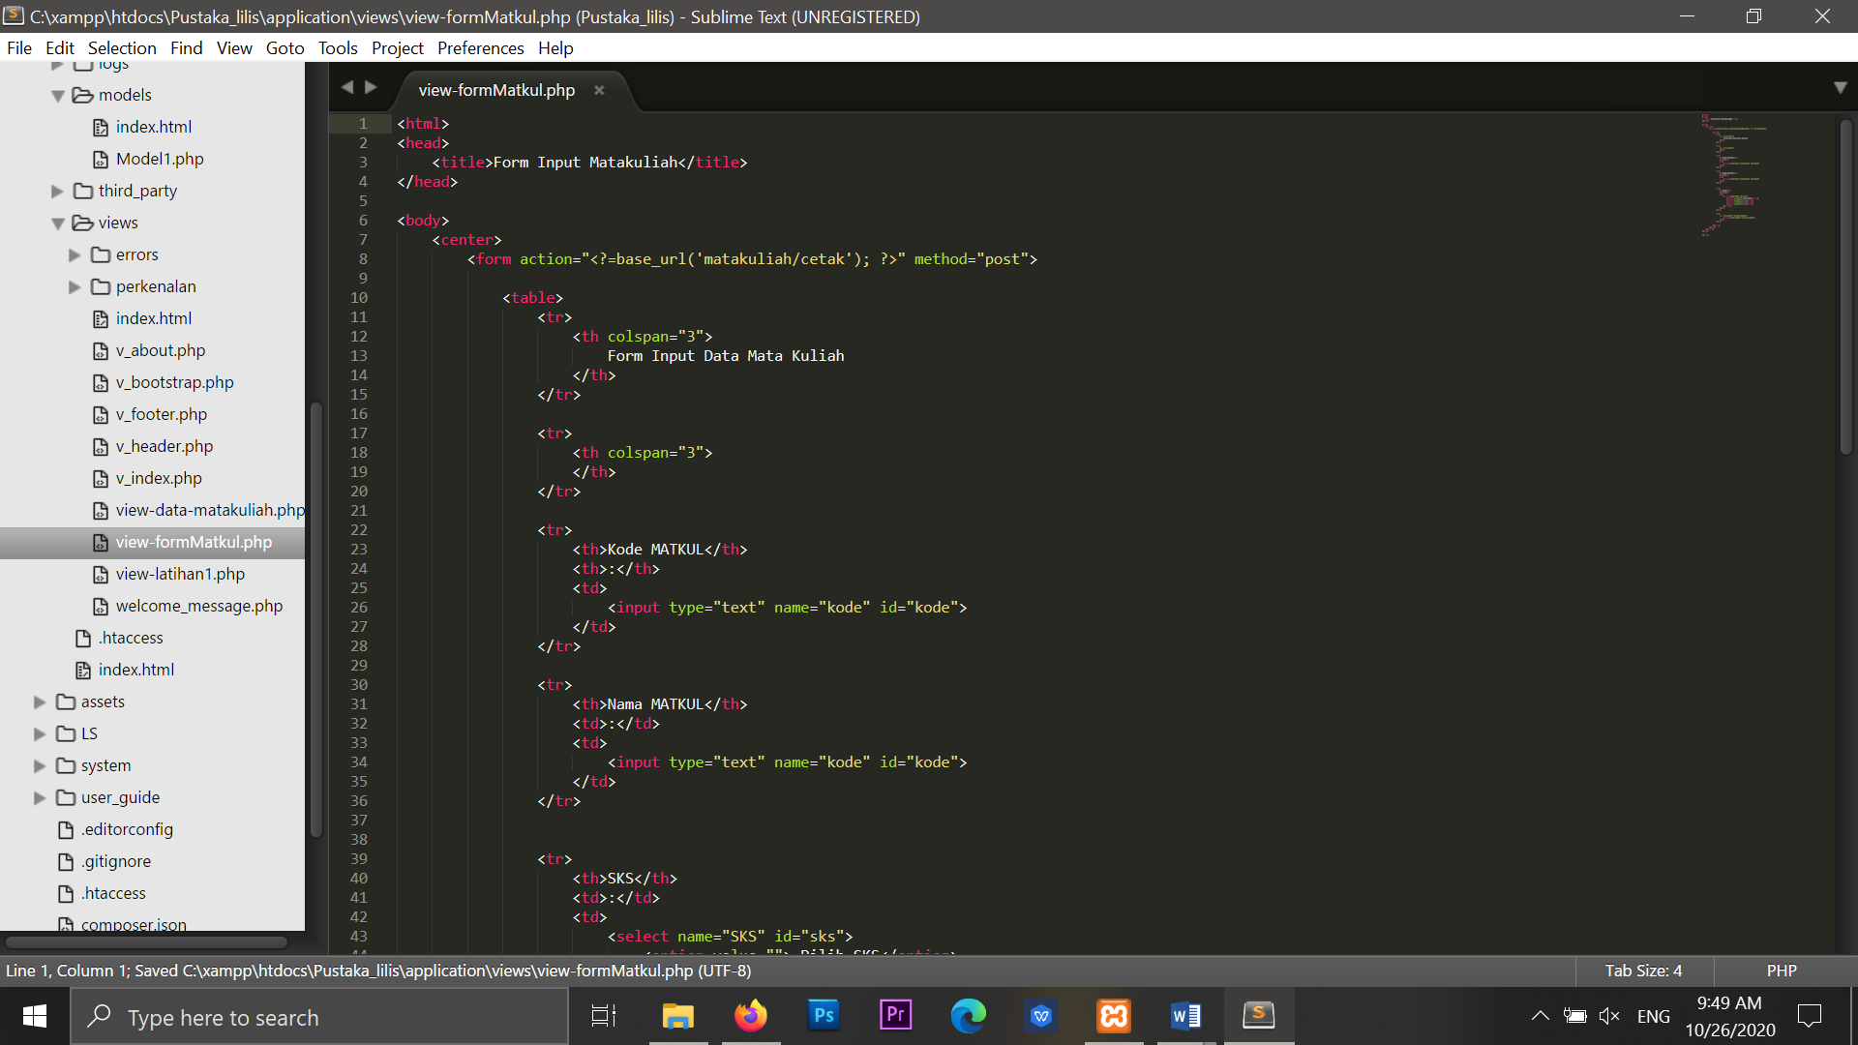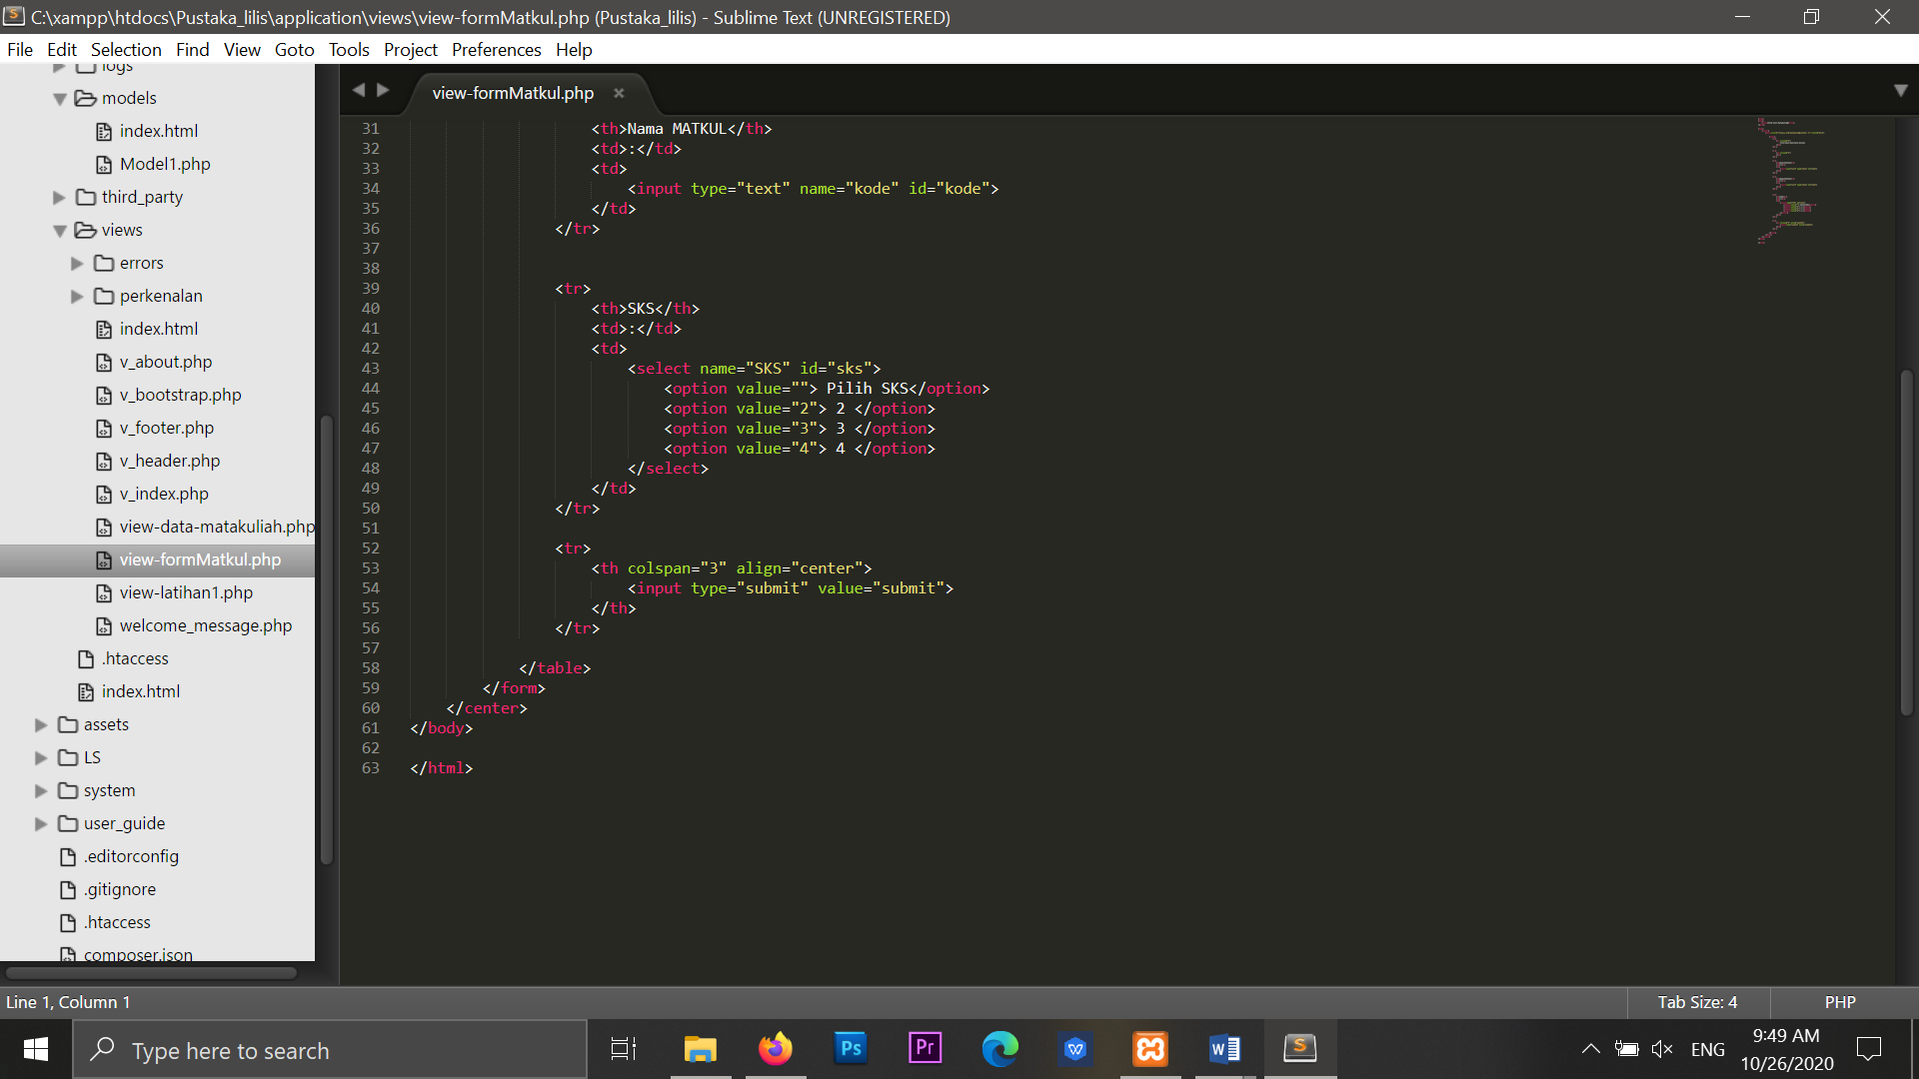

1. URL

<http://localhost/Pustaka_lilis/matakuliah>

1. Capture Hasil

